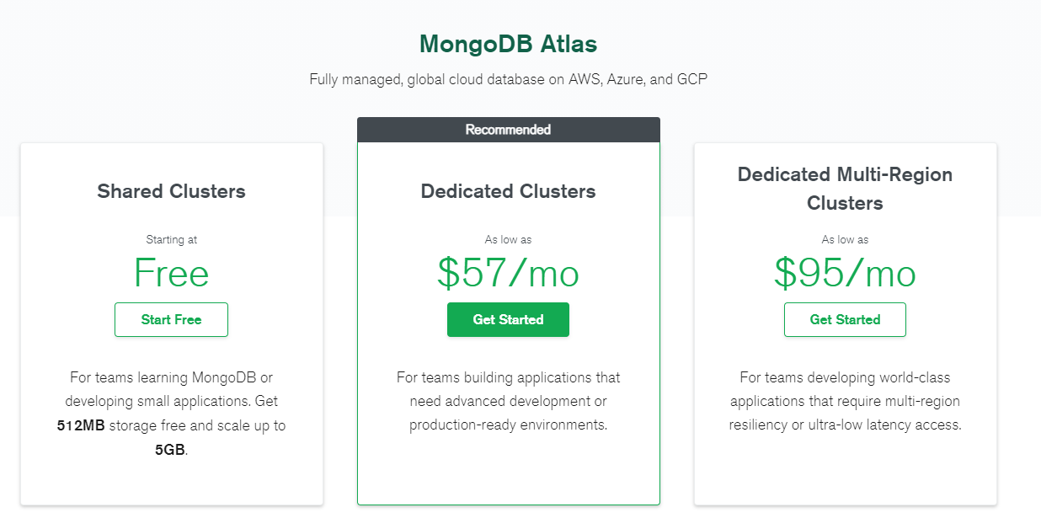

Firebase



Just in case if we use Sign up with Phone number or with (faecbook or google) account

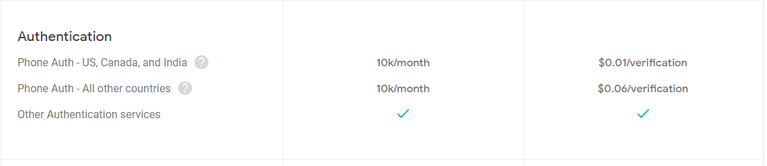

Frontend Hosting

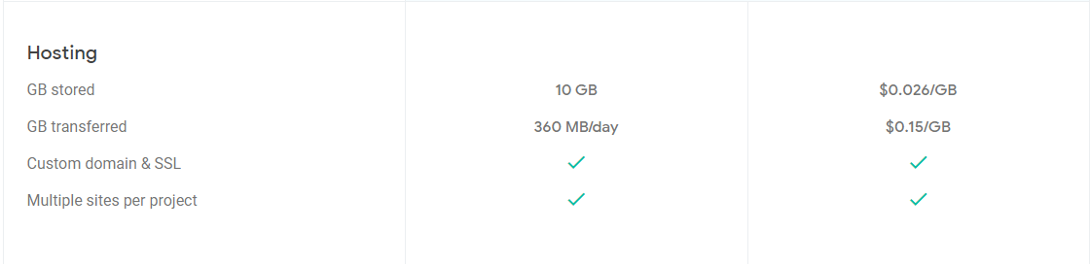

Firebase notification



Remote config to edit global common variables



Backend Hosting ( GC App Engine )

Selon this calculator

<https://cloud.google.com/products/calculator#id=53fd480e-57e6-45bb-afcc-13d04873f888>

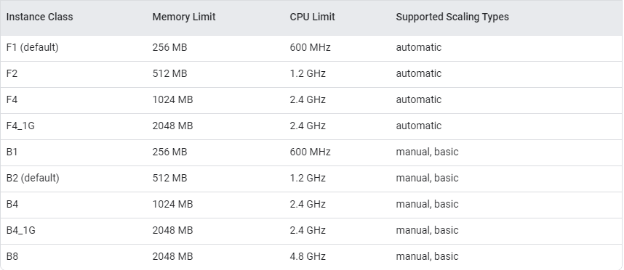

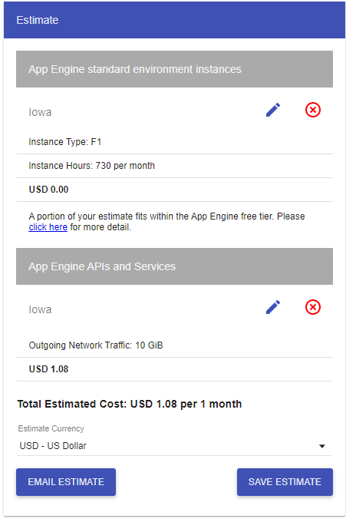F1 + 10GB outgoing network traffic = 1.08$

Network resources

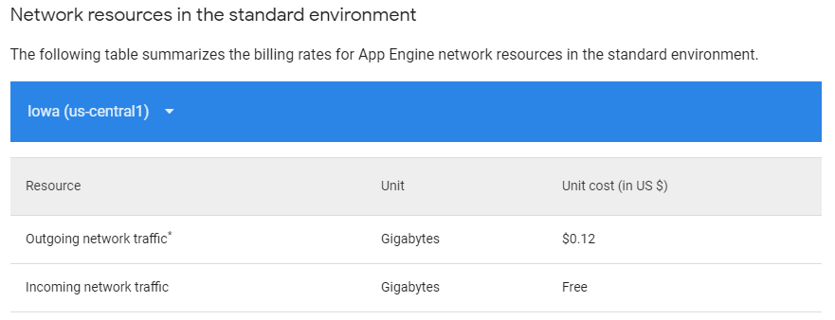

Instance Type

